NSW Health | Beat the Heat social copy
 | November 2023
v1 | www.health.nsw.gov.au

Social
Tile example (please download file to use in channel) | Social copy
Aware - Hot weather can be dangerous  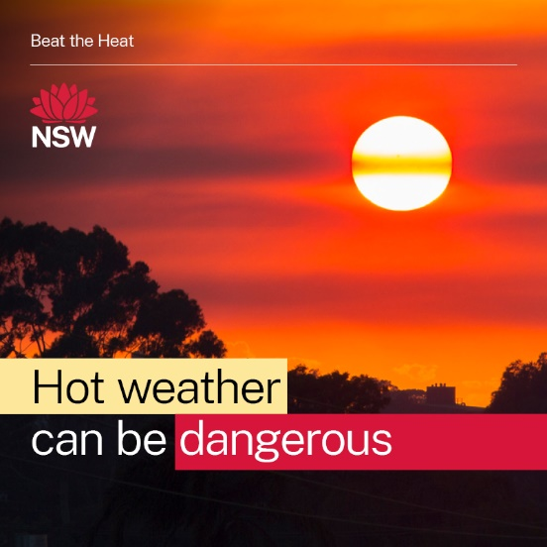 | Everyone can be affected by hot weather. It’s important to be aware of the health effects of heat exposure and to know what actions you can take to protect yourself and others.  Learn how to Beat the Heat this summer:  health.nsw.gov.au/beattheheat
Aware - Hot weather can be dangerous for babies and children  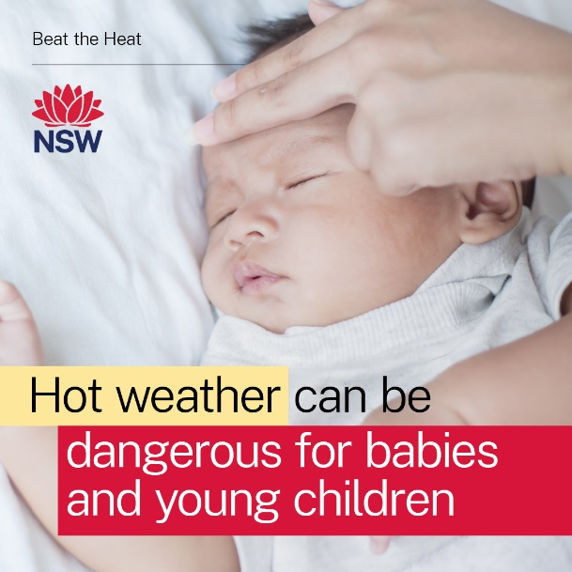 | Hot weather can be dangerous for anyone. Are you or your loved ones at risk of heat related illness? People most at risk include anyone aged 65 years and over and babies and young children.  Be prepared. Talk to your family, neighbours and friends. Have a heat plan in place to help protect you and your loved ones during the summer months. Learn more: health.nsw.gov.au/beattheheat
Prepare - Home for a Heatwave  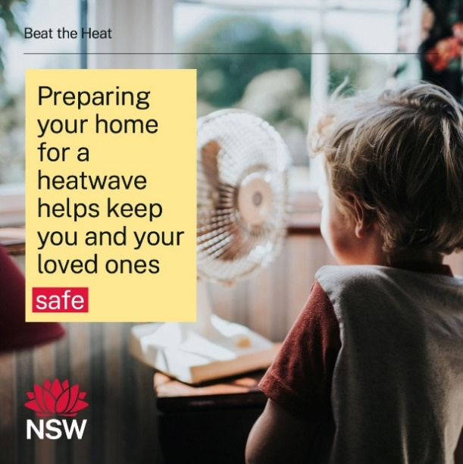 | Don't wait for scorching hot days to think about keeping your home cool this summer. Prepare now to keep your home cool in the heat. Visit:  health.nsw.gov.au/beattheheat
Prepare - Keep in touch  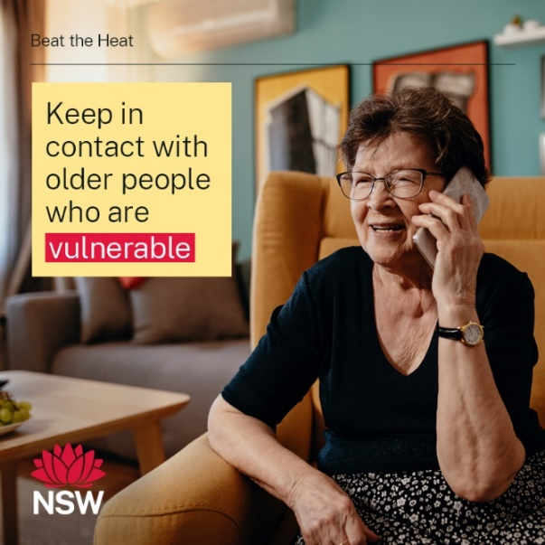 | Hot days are hard on everyone. Please check in on older or vulnerable family and friends to see how they're coping, especially if they live alone. Do they have enough food and medications at home? Do they need some shopping or other errands done for them?  Prepare to Beat the Heat this summer: health.nsw.gov.au/beattheheat
Tips - Keep cool in the heat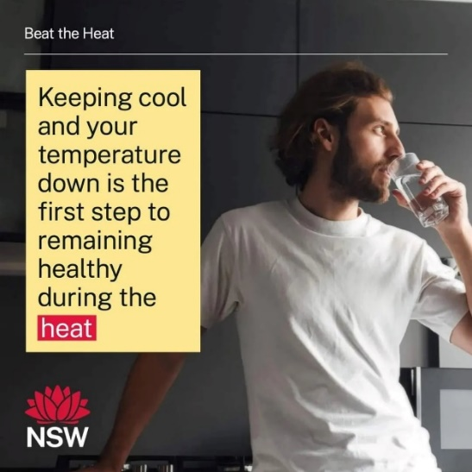 | Even young, fit and healthy people can be affected by hot weather. Make sure you drink plenty of water and stay as cool as possible. Avoid exercising in the hottest part of the day and if you have to work outside, stay hydrated and wear sun protection every day.  Learn more: health.nsw.gov.au/beattheheat
Tips – Stay cool and keep hydrated 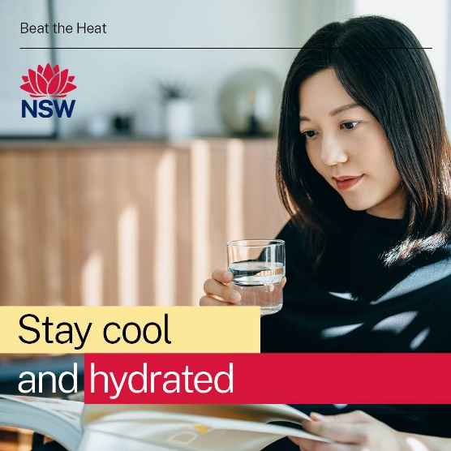 | During hot weather, make sure you drink plenty of water and stay as cool as possible. Avoid exercising in the hottest part of the day and if you have to work outside, stay hydrated and wear sun protection every day.  Learn more: health.nsw.gov.au/beattheheat
Tips – Wet your skin with cool water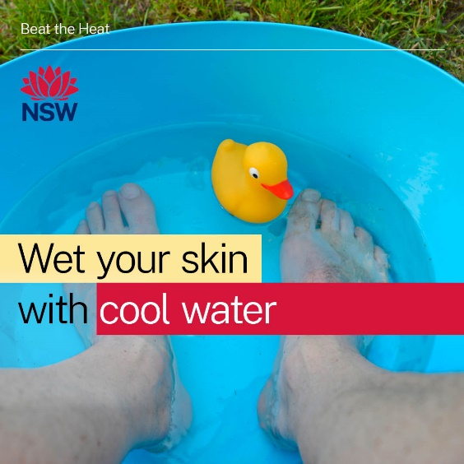 | Everyone can be affected by hot weather. It’s important to keep cool and stay hydrated in the heat. For more tips, visit: health.nsw.gov.au/beattheheat
Tips – Stay cool and keep hydrated - Kids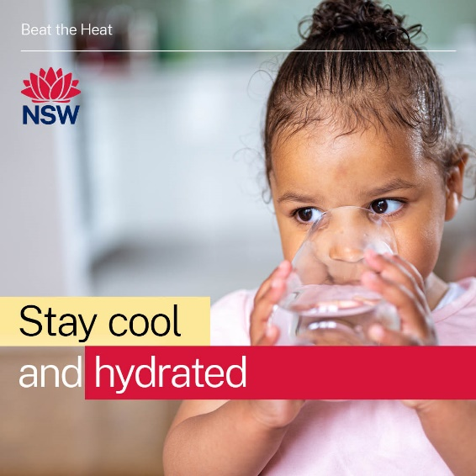 | Children are less able to control their own body temperature (and they're also more likely to run around on hot days!). Babies and young kids dehydrate quickly. Make sure they drink regularly and stay cool in shady areas this summer. Learn more: health.nsw.gov.au/beattheheat
Tips – Dress in light clothing - Kids 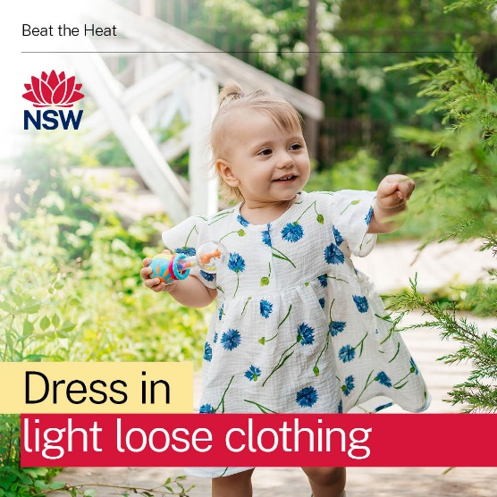 | Children are less able to control their own body temperature. Make sure they drink regularly and stay cool in shady areas this summer. Learn more: health.nsw.gov.au/beattheheat

NSW Health
NSW Ministry of Health  1 Reserve Road  St Leonards NSW 2065 | Office hours:  Monday to Friday  9.00am — 5.00pm  W: www.health.nsw.gov.au

