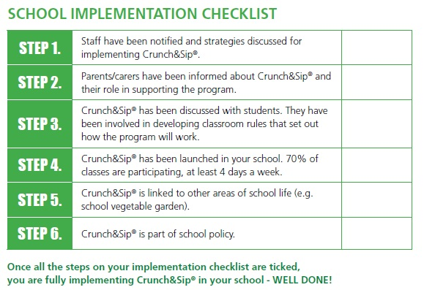
Please fill in the details below so that you can receive your school’s Crunch&Sip® certificate and fence sign.
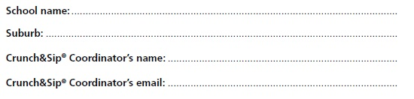
Send a copy of this completed page to MOH-LLWS@health.nsw.gov.au and a Local Health District Health Promotion Officer will be in contact with you shortly.

