Youth Friendly Checklist
for Health Services

Service name | Date
Address | Phone
Completed by | Email

Instructions for completion

This checklist is for service providers to plan how to improve health services for young people. The checklist is based on research into young people’s access to services and the Youth Health Better Practice Framework.

Who is the checklist for?
This self-assessment checklist is for services that see young people, including services that have a generalist focus but do see some young people. The checklist is relevant to all health services in primary, community and acute healthcare settings.
“Adolescents need explicit attention. Adolescents are not simply big children or small adults. Unique developmental processes take place during this period. Adolescents have specific characteristics that need to be taken into consideration in policies and programmes and in the strategies to reach this section of the population with health promotion, prevention, treatment and care.”
(World Health Organisation, 2014)

Why is this checklist needed?
- Young people may be reluctant consumers of health services and delay seeking help. Services should promote themselves to young people to break down barriers.
- Adolescence is a time of increased risk-taking behaviour, so is a key time to promote healthy behaviours. Intervention in adolescence can have long term health benefits and prevent serious long-term conditions.
- Some young people are more vulnerable due to disabilities, chronic illnesses or experiencing abuse. Others are marginalised because of sexual orientation or cultural background.
- Research has provided new insights into how to make services more accessible and welcoming to young people.

How to use this checklist
- The self-assessor should work through the questions in the tool, selecting ‘yes’, ‘no’ or ‘partly achieved’.
- The checklist includes spaces for services to describe their current approach as well as spaces for services to plan how to improve. It is recognised that service approaches vary between areas and so specific service models have not been prescribed.
- The checklist can be completed by an individual on behalf of a service, or can be used to enable team discussion and planning.
- Young people can be involved in leading the review process, for example by using observation and interview strategies to complete the checklist.
- This checklist can be saved electronically, enabling sharing and collation.
- By collating results, areas can identify recurring themes that can be addressed through collaborative projects, sharing resources to improve services.
- Repeated use of the checklist can capture improvements over time.

Need extra help?
- More information about the better practice principles can be found in the Youth Health Better Practice Factsheets located on the NSW Kids and Families website.
- Some services may seek assistance to use the checklist from their Youth Health Coordinator, Youth Health Service or Youth Interagency network
- If you have any queries about the checklist, please contact Youth Health and Wellbeing, NSW Kids and Families www.kidsfamilies.health.nsw.gov.au
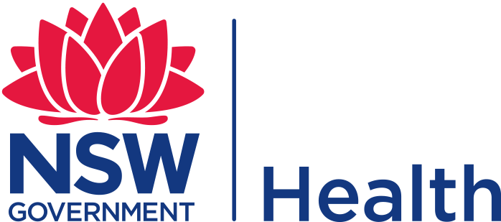
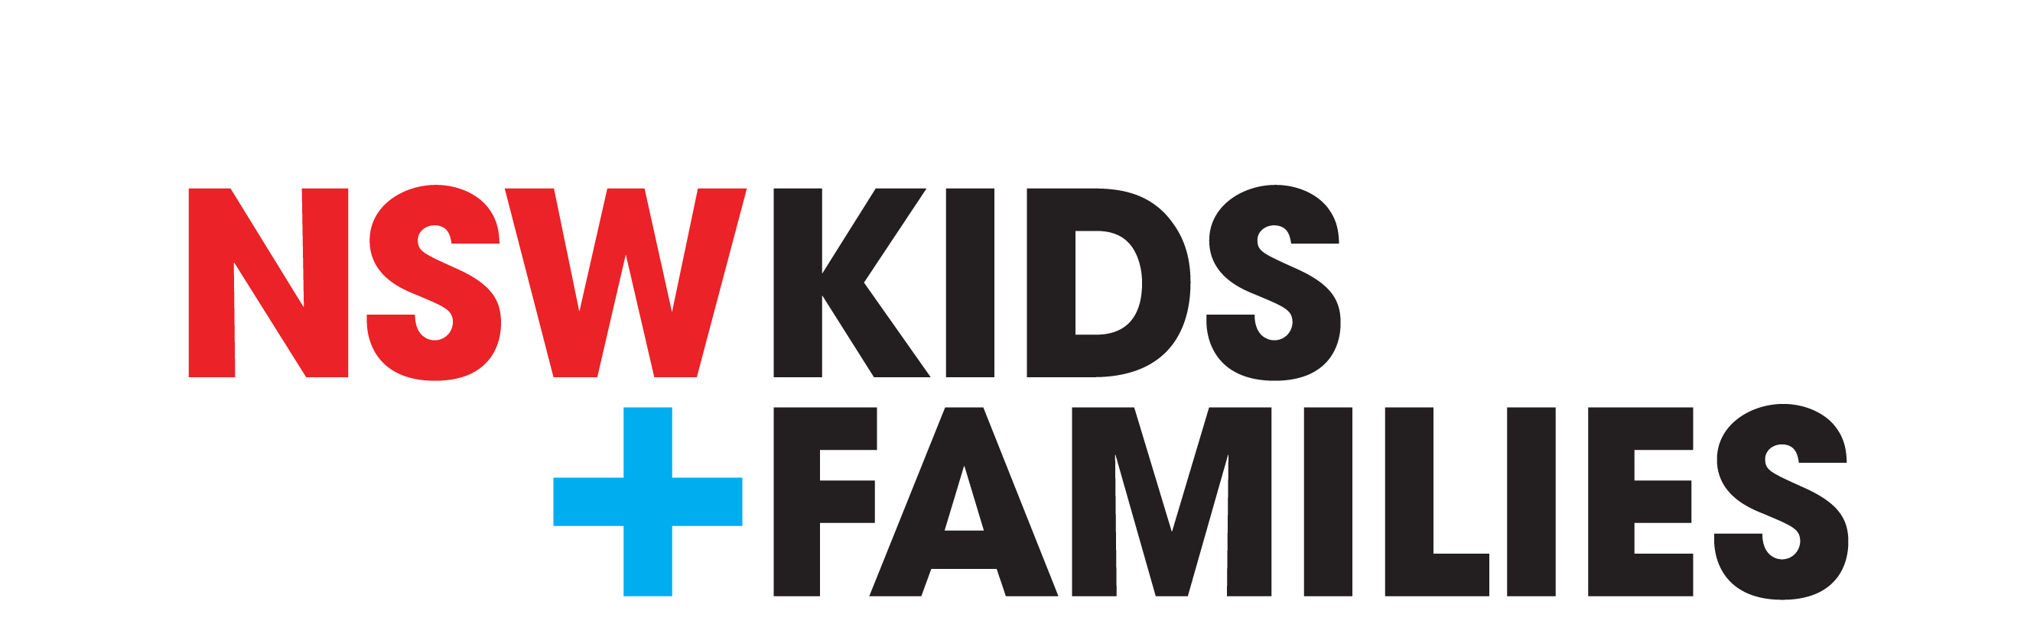

1. Accessibility | yes | part | no
Does your service have a promotional strategy targeting young people?
Is the confidentiality policy widely publicised to young people, their parents and carers?
Does your service use creative, innovative strategies including technology and activity based approaches to improve young people’s engagement with health services?
Are services provided free, or at a cost affordable to young people?
Can young people access the service easily?
Is the service open when young people can access it?
Is the service sensitive to the cultural and language needs of young people?
Is it possible for young people to drop in and use the service without having to make an appointment?
Is there capacity to offer longer sessions to deal with complex issues that may arise?
Are waiting rooms and facilities welcoming, with health promotion materials that appeal to young people?
Please describe:

Recommended actions:

2. Evidence-based approach
Does your service regularly look at the latest research evidence to make sure your practice is up to date? For example, are youth health checks (including HEEADSSS assessments) routinely used with young people? Or do you have a system in place to receive regular research updates?
Please describe:
Recommended actions:

3. Youth participation
Does your service involve young people in service planning and review?
Please describe:

Recommended actions:

4. Collaboration and partnerships
Does your service work collaboratively with others to help young people navigate the health system? For example, by providing co-location, outreach and referral facilitation?
Please describe:

Recommended actions:

5. Professional development
Do staff receive training, supervision and support in working with young people aged 12-24 and youth health issues?
Please describe:

Recommended actions:

6. Sustainability
Does your service develop sustainability strategies? For example starting with small initiatives or changes, and gradually building on success, and networking with other providers?
Please describe:

Recommended actions:

7. Evaluation
Does your organisation evaluate its services, including seeking feedback from young people?
Please describe:

Recommended actions:

